Software Requirement Specification(SRS)
1.Introduction
1.1.Purpose:
This SRS document describes the functional and non-functional requirements of the Prashikshan-Internship Management System. The purpose of this system is to manage internship activities between students, faculty, companies, and administration in an organized and automated manner.

1.2.Scope:
- It allows Students to register, apply for Internships , Submit Logbooks , Attempt Skill Tests .
- Allows Companies to register, Post Internships, View Applicants, and Select Students.
- Allows faculty to Review Logbooks , and Evaluate Students.
- Allows Admin to Approve Companies, Manage Users, Generate Reports , and Issue Certificates.

1.3.Definitions, Acronyms, Abbreviations:
- SRS – Software Requirement Specifications
- UI – User Interface
- DFD – Data Flow Diagram
- DB – Database
- Admin – System Administrator
- Logbook - Internship activity report submitted by students

1.4.References:
1.5.Overall Description:
- The system is an online internship management platform that integrates students, faculty, companies, and administration under a single system.
- It manages internship posting, application, logbook validation, evaluation, skill tests, and certificate generation.

2.Overall Description
2.1.Product Perspective:
Prashikshan is a standalone web-based system that uses a centralised database, provides a role-based access control for different type of users , operates on client-server architecture.
2.2.Product Functions:
- Student : Register, Login , View Internships , Apply For Internships, Submit logbook, Attempt skill test, View learning resources.
- Company: Register, Post internship, View applicants, Select student.
- Faculty: Review logbook, Evaluate student, Generate reports, Upload learning resources.
- Admin: Approve company, Manage users, Issue certificates, Generate reports

2.3.User Characteristics:
- Student: Basic computer knowledge, internet access.
- Company: Able to manage internship postings and applicant review.
- Faculty: Moderate system knowledge, able to review and evaluate student performance.
- Admin: Technical knowledge, system management skills.

2.4.User Constraints:
- Internet connection required.
- Users must have valid login credentials.
- Students must meet eligibility criteria.
- Only approved companies can post internships.

2.5.Assumptions and Dependencies:
- Users have valid login credentials.
- System depends on server availability.
- Database connectivity must be active.
- Companies provide correct internship data.

2.6.Apportioning Requirements:
Future enhancements may include:
- Mobile application version.
- Integration with LinkedIn or placement portals.
- AI-based student recommendation system.

3.Specific Requirements
3.1 Interface Requirements:
3.1.1 External Interface:
- Web browser interface (Chrome, Firefox, Edge)
- Responsive UI
3.1.2 Hardware Interface:
- Server system
- Client device (PC/Laptop/Tablet)
- Internet connectivity

    - Software Interface:
- Web server
- Backend (Java/PHP/Node.js)
- Database (MySQL)
3.1.4 Communication Interface:
- HTTP/HTTPS protocol
- Secure login authentication
- Email notifications for internship approval

  - Functional Requirements
3.2.1 Use Case Model / Information Flows:

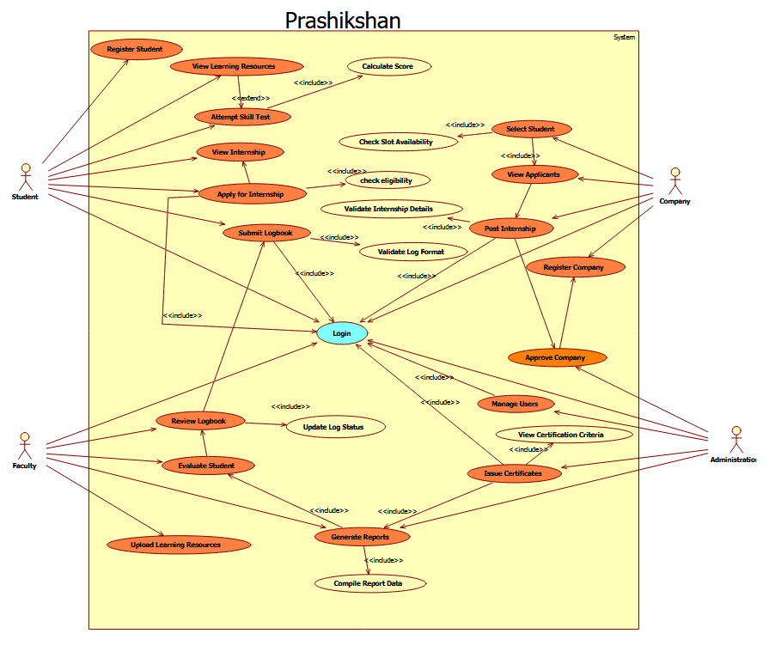

3.2.2 Use Case Specifications:
Field | Details
Use Case ID | UC-02
Use Case Name | View Internships
Actors | Student
Description | Allows student to view available internship opportunities
Preconditions | Student logged in
Postconditions | Internship list displayed
Normal Flow | 1. Login 2. Select “View Internships” 3. System displays internship list
Alternate Flow | A1: No internships available
Priority | High
Frequency | Multiple times
Business Rules | Only approved internships shown
Assumptions | Companies have posted internships

Field | Details
Use Case ID | UC-01
Use Case Name | Student Registration
Actors | Student
Description | Allows a new student to create an account by providing personal and academic details and uploading resume.
Preconditions | Student not already registered; System available
Postconditions | Account created; Student can log in
Normal Flow | 1. Open registration page 2. Enter details 3. Upload resume 4. Submit form 5. System validates 6. Account created
Alternate Flow | A1: Invalid data → Error shown → Student corrects
Priority | High
Frequency | Once per student
Business Rules | Resume must be PDF; Email must be unique
Assumptions | Student has valid credentials

3.
Field | Details
Use Case ID | UC-03
Use Case Name | Apply for Internship
Created By | Project Team
Last Updated By | Project Team
Date Created | 23-02-2026
Date Last Updated | 23-02-2026
Actors | Student
Description | Allows a student to apply for an internship.
Preconditions | Student logged in. Internship active.
Post Conditions | Application recorded. Status set to Pending.
Normal Flow | 1. Student selects internship.2. Clicks Apply.3. System checks eligibility.4. Application stored.
Alternate Flows | A1: Not eligible. A2: Deadline expired.
Priority | High
Frequency | Multiple times
Business Rules | One application per internship.
Assumptions | Student profile complete.
4.
Field | Details
Use Case ID | UC-04
Use Case Name | Submit Logbook
Created By | Project Team
Last Updated By | Project Team
Date Created | 23-02-2026
Date Last Updated | 23-02-2026
Actors | Student
Description | Allows student to submit internship logbook entries.
Preconditions | Internship active.
Post Conditions | Log stored. Pending review.
Normal Flow | 1. Student enters task details.2. Submits entry.3. System stores log.
Alternate Flows | A1: Invalid format.
Priority | High
Frequency | Daily
Business Rules | Format restrictions apply.
Assumptions | Internship ongoing.

5.
Field | Details
Use Case ID | UC-05
Use Case Name | Attempt Skill Test
Created By | Project Team
Last Updated By | Project Team
Date Created | 23-02-2026
Date Last Updated | 23-02-2026
Actors | Student
Description | Allows student to attempt skill assessment.
Preconditions | Student logged in.
Post Conditions | Skill score generated.
Normal Flow | 1. Student starts test.2. Answers questions.3. Submits test.4. Score displayed.
Alternate Flows | A1: Time expired.
Priority | Medium
Frequency | As required
Business Rules | Time-bound test.
Assumptions | Questions preloaded.

6.
Field | Details
Use Case ID | UC-06
Use Case Name | View Learning Resources
Created By | Project Team
Last Updated By | Project Team
Date Created | 23-02-2026
Date Last Updated | 23-02-2026
Actors | Student
Description | Allows access to learning materials.
Preconditions | Student logged in.
Post Conditions | Resources displayed.
Normal Flow | 1. Student selects module.2. System displays content.
Alternate Flows | A1: No resources available.
Priority | Medium
Frequency | Multiple times
Business Rules | Category-based access.
Assumptions | Resources uploaded.

7.
Field | Details
Use Case ID | UC-07
Use Case Name | Register Company
Created By | Project Team
Last Updated By | Project Team
Date Created | 23-02-2026
Date Last Updated | 23-02-2026
Actors | Company
Description | Allows company to create account.
Preconditions | Company not registered.
Post Conditions | Account created (Pending approval).
Normal Flow | 1. Enter company details. 2. Submit form. 3. System saves data.
Aternate Flows | A1: Invalid data.
Priority | High
Frequency | Once per company
Business Rules | Admin approval required.
Assumptions | Valid company credentials.

8.
Field | Details
Use Case ID | UC-08
Use Case Name | Post Internship
Created By | Project Team
Last Updated By | Project Team
Date Created | 23-02-2026
Date Last Updated | 23-02-2026
Actors | Company
Description | Allows posting internship opportunities.
Preconditions | Company approved and logged in.
Post Conditions | Internship listed.
Normal Flow | 1. Enter internship details.2. Submit.3. Internship published.
Alternate Flows | A1: Invalid deadline.
Priority | High
Frequency | Multiple times
Business Rules | Limited slots allowed.
Assumptions | Company logged in.

9.
Field | Details
Use Case ID | UC-09
Use Case Name | View Applicants
Created By | Project Team
Last Updated By | Project Team
Date Created | 23-02-2026
Date Last Updated | 23-02-2026
Actors | Company
Description | View list of student applicants.
Preconditions | Internship exists.
Post Conditions | Applicant list displayed.
Normal Flow | 1. Select internship.2. View applicants.
Alternate Flows | A1: No applicants available.
Priority | Medium
Frequency | Multiple times
Business Rules | Only for posted internships.
Assumptions | Students have applied.

10.
Field | Details
Use Case ID | UC-10
Use Case Name | Select Student
Created By | Project Team
Last Updated By | Project Team
Date Created | 23-02-2026
Date Last Updated | 23-02-2026
Actors | Company
Description | Select student for internship.
Preconditions | Applicants available.
Post Conditions | Student selected.
Normal Flow | 1. Review applicants.2. Select student.3. Confirm selection.
Alternate Flows | A1: Slot already filled.
Priority | High
Frequency | Per internship
Business Rules | Cannot exceed slot limit.
Assumptions | Applicant list available.

11.
Field | Details
Use Case ID | UC-11
Use Case Name | Review Logbook
Created By | Project Team
Last Updated By | Project Team
Date Created | 23-02-2026
Date Last Updated | 23-02-2026
Actors | Faculty
Description | Allows faculty to review internship logbook entries.
Preconditions | Student submitted log entries. Faculty logged in.
Post Conditions | Logbook marked Approved/Rejected. Student notified.
Normal Flow | 1. Faculty logs in.2. Selects student logbook.3. Reviews entries.4. Approves or rejects.5. System updates status.
Alternate Flows | A1: Logbook incomplete → Reject.
Priority | High
Frequency | Multiple times during internship
Business Rules | Only assigned faculty can review. Approval required for report generation.
Assumptions | Log entries stored properly.

12.
Field | Details
Use Case ID | UC-12
Use Case Name | Evaluate Student
Created By | Project Team
Last Updated By | Project Team
Date Created | 23-02-2026
Date Last Updated | 23-02-2026
Actors | Faculty
Description | Allows faculty to evaluate student internship performance.
Preconditions | Internship completed. Logbook reviewed.
Post Conditions | Evaluation score recorded.
Normal Flow | 1. Select student.2. Enter remarks and score.3. Submit evaluation.4. System stores evaluation.
Alternate Flows | A1: Missing evaluation fields.
Exceptions | System failure during submission.
Priority | High
Frequency | Once per internship
Business Rules | Evaluation must follow grading criteria.
Assumptions | Internship completed successfully.

13.
Field | Details
Use Case ID | UC-13
Use Case Name | Generate Reports
Created By | Project Team
Last Updated By | Project Team
Date Created | 23-02-2026
Date Last Updated | 23-02-2026
Actors | Faculty, Admin
Description | Generates internship progress and performance reports.
Preconditions | Internship data available. User logged in.
Post Conditions | Report generated and displayed/downloaded.
Normal Flow | 1. Select report type.2. System collects data.3. System compiles report.4. Report displayed.
Alternate Flows | A1: No data available.
Exceptions | Report generation failure.
Priority | Medium
Frequency | As required
Business Rules | Only authorized roles can generate reports.
Assumptions | Data stored correctly.

14.
Field | Details
Use Case ID | UC-14
Use Case Name | Upload Learning Resource
Created By | Project Team
Last Updated By | Project Team
Date Created | 23-02-2026
Date Last Updated | 23-02-2026
Actors | Faculty
Description | Allows faculty to upload learning materials.
Preconditions | Faculty logged in.
Post Conditions | Resource stored and available to students.
Normal Flow | 1. Select upload option.2. Enter title and category.3. Upload file/link.4. System validates and stores resource.
Alternate Flows | A1: Invalid file format.
Exceptions | Upload failure.
Priority | Medium
Frequency | As required
Business Rules | Only authorized roles can upload.
Assumptions | Storage available.

15.
Field | Details
Use Case ID | UC-15
Use Case Name | Approve Company
Created By | Project Team
Last Updated By | Project Team
Date Created | 23-02-2026
Date Last Updated | 23-02-2026
Actors | Admin
Description | Allows admin to approve or reject company registrations.
Preconditions | Company registered. Admin logged in.
Post Conditions | Company status updated. Company notified.
Normal Flow | 1. View pending companies.2. Review details.3. Approve or reject.4. System updates status.
Alternate Flows | A1: Invalid company details.
Exceptions | Database update failure.
Priority | High
Frequency | As needed
Business Rules | Only admin can approve.
Assumptions | Company registration exists.

16.
Field | Details
Use Case ID | UC-16
Use Case Name | Issue Certificate
Created By | Project Team
Last Updated By | Project Team
Date Created | 23-02-2026
Date Last Updated | 23-02-2026
Actors | Admin
Description | Allows admin to generate internship completion certificate.
Preconditions | Internship completed. Logbook approved. Evaluation completed.
Post Conditions | Certificate generated. Student can download certificate.
Normal Flow | 1. Select completed internship.2. Click issue certificate.3. System generates certificate.4. Certificate stored and available.
Alternate Flows | A1: Internship not completed.
Exceptions | Certificate generation failure.
Priority | High
Frequency | Once per completed internship
Business Rules | All approvals required before issuing certificate.
Assumptions | Student fulfilled all requirements.

17.
Field | Details
Use Case ID | UC-17
Use Case Name | Manage System
Created By | Project Team
Last Updated By | Project Team
Date Created | 23-02-2026
Date Last Updated | 23-02-2026
Actors | Admin
Description | Allows admin to manage users, modules, and system configurations.
Preconditions | Admin logged in.
Post Conditions | System settings updated.
Normal Flow | 1. Select management option.2. Update user/module settings.3. Save changes.4. System updates database.
Alternate Flows | A1: Invalid configuration.
Exceptions | System update failure.
Priority | Medium
Frequency | As required
Business Rules | Only admin has management rights.
Assumptions | Proper access control implemented.

  - Performance Requirements
- System should support 500+ concurrent users
- Response time < 3 seconds
- Report generation < 5 seconds

  - Logical Database Requirements
- Relational Database (MySQL)
- Tables:

